**Planning and Estimating the Cost of Constructing Sustainable Housing in Kenya.**

By

Fredah Kioko- 103428

Lydia Kahuria-110789

Lilian Thairu- 111878

Melody Muthama- 111445

An Information Systems Project Proposal Submitted to the Faculty of Information Technology in partial fulfilment of the requirements for the award of the Bachelor’s Degree of Business Information Technology

Research Methodology

**Strathmore University**

April 2020

# Declaration and Approval

We hereby declare that, to the best of our knowledge, this project has not been submitted to any other University for the award of a Bachelor’s Degree.

***Delete this comment after correcting***This page should be numbered as roman number ii and not I. The title page should however stay as it is with no page number on it.

Student Number:

Sign: ________________________ Date: ________________________

Student Number:

Sign: ________________________ Date: ________________________

Student Number:

Sign: ________________________ Date: ________________________

# Abstract

Planning and Estimating the cost of building sustainable housing in Kenya is the

Purpose-Avoid demolition of houses that lead to homelessness

Discover cheap but sustainable building materials

# Table of Contents

Table of Contents

Declaration and Approval i

Abstract ii

Table of Contents iii

List of Tables vi

List of Figures vii

Chapter 1: Introduction 1

1.1 Background 1

1.2 Challenge Definition 1

1.3 Aim / General Objective {Use one of these two alternatives} 2

1.4 Specific Objectives 2

1.5 Justification 2

1.6 Scope and Limitation 2

Chapter 2: Literature Review 3

2.1 Introduction [can be necessary] 3

Related areas accessed or read 3

Chapter 3: Methodology 4

3.1. Introduction 4

3.2. Agile Development Methodology 6

Explain each Phase/stage of the methodology e.g. The following is just an example: 7

3.2.1 System Requirements Phase 7

3.2.2 System Planning Phase 7

3.2.3 System design phase: 8

*What will you do under design?* 8

3.2.4 System Development 8

e.g. 3.8.1. Database development tools 8

3.8.2. Programming tools 8

3.2.5 System Release 8

3.2.6 System Track and Monitor 8

3.3. Project Milestones/ Schedule 8

3.4. Impact Assessment 8

Chapter 4: Empathy, Problem Definition and Ideation 10

4.1. Empathy 10

4.2. Problem Definition 10

4.2. Ideation 10

References 11

Appendices 12

# List of Tables

# List of Figures

**No table of figures entries found.**

# Chapter 1: Introduction

## 1.1 Background

*[Should be more than three paragraphs. Include citations]*

## 1.2 Challenge Definition

At least 1000 people In Kenya have lost their houses due to government demolition and do not get any compensation (Omullo, 2020). The tenants are issued eviction notices late hence low income bracket time tenants do not have ample time to prepare. It has also been proven that some of the demolitions are illegal documentations that are created to back their crude ways (Maritim, 2020). Therefore, this poses as a threat to the locals.

Furthermore, there is an Affordable Housing Programme (AHP) that has been created by the government known as Boma Yangu that aims to facilitate ownership of affordable and decent housing for Kenyans (Kairu, 2019). However, issues have risen concerning this project. People claiming to be in a position to allocate the locals houses in the affordable housing program are taking advantage of Kenyans (Barasa, 2019). Furthermore, the Kenyan government is facing a difficult task of convincing foreign investors to help finance the program (Nkirote, 2018).

## 1.3 Aim / General Objective {Use one of these two alternatives}

*[This is basically your aim. Explained in one paragraph]*

The aim must be written in paragraph format. It is also called the purpose of the project.

## 1.4 Specific Objectives

*[These are those things that you will have to do to be able to develop the system that you intend to develop. E.g. to investigate the challenges facing those that will use the system; To Design the proposed system; etc]*

1. To ...

## 1.5 Justification

*[This is the importance of the project / the value that it will add.]*

## 1.6 Scope and Limitation

*[The extent to which you will develop the application]*

# Chapter 2: Literature Review

## 2.1 Introduction [can be necessary]

## Related areas accessed or read

*[You might have some subtitles here depending on the items that you are refereeing to at the initial thinking stage. You can have 3 to 6 subtopics: this could constitute about 2 to 4 pages: Note: The words* ***Related areas Accessed or read*** *is not a topic but rather your subtopics from this section]*

The reduction in data storage costs has precipitated the storage of data comparatively intensive than ever before in measurable aspects. Moreover, the past decade has revolutionized the way companies conduct business. Packaged applications from SAP, PeopleSoft, Oracle and the others have been embraced as a means of improving operational efficiency. The emphasis has been on automation process and not on leveraging information (Liautaud & Hammond, 2001).

Liu and Meng (2006) propose a technique for web database integration and highlight a number of challenges. With the rapid development of Web, more and more accessible databases are available in the Web. Such databases are usually called Web database (or WDB in short) by researchers.

# Chapter 3: Methodology

## 3.1. Introduction

This chapter highlights the methodology to be used in the research and development of the web application that will be used in the planning and cost estimation of constructing houses in Kenya as an addition to the Boma Yangu app in response to the specific objectives stated in chapter one. The methodology chosen to deliver in this study is Agile methodology and the cost estimation Technique to be applied is the Linear Cost Function.

**Cost Estimation**

Cost estimation may be defined as a study which attempts to predict the relationship between costs and the activity level or cost driver that causes those costs. The importance of this is:-

1. It assists in estimating the future expenditure (cost prediction) as the expenditure will depend on the cost of the respective activities.
2. Cost estimation is useful in business planning, cost control, performance evaluation and decision making.

A cost function is a mathematical description of how a cost changes with changes in the level of an activity relating to that cost often estimate cost functions based on two assumptions:

* Variations in the level of a single activity level (the cost driver) explain the variations in the related total costs.
* Cost behavior is approximated by a linear cost function within the relevant range.

Costs are estimated using the following linear cost function.

𝒀=𝒂+𝒃𝒙

Where;

Y =Total Cost

X =Activity Level/Cost Driver

a = Total Fixed Cost

bx = Total Variable cost

b =Variable Cost per unit.

This method will be used in the estimation of housing construction using ecological and locally sourced materials as well as the labor and time invested in each housing project.

**Agile methodology**

Agile methodology is a practice that promotes continuous iteration of development and testing throughout the software development lifecycle of the project (Ihor Feoktistov, 2020). It covers many activities from understanding why the system should be built, studying the feasibility of the project as well as looking at other existing tools of a similar nature, analysing problems and challenges involved, choosing the system design and architecture, implementing, validating and testing it up to delivering the system to the user as a product (Jira, 2019). In the Agile model, both development and testing activities are concurrent. Agile development is incremental (multiple releases), cooperative (strong collaboration between developer and client) (QMS Academy, 2016). This approach is the most desirable, efficient and effective as described below:

1. It is a project management process that encourages frequent inspection of the project and adaptation, this aspect.
2. It encourages a leadership philosophy that encourages self-organisation and accountability.
3. It encompasses a set of engineering best practices that allow for rapid delivery of high quality software.
4. It is a business approach that aligns development with customer needs and company goals
5. It is easy to understand, scalable and flexible to any changes made or adapted over time.
6. It is easy to coordinate with existing works since we are making an improvement to a web application.

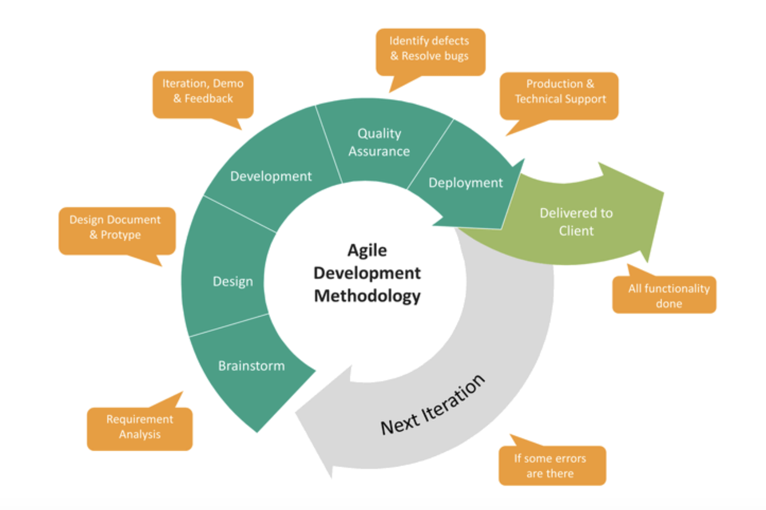

Figure 0.1Agile Software Development life Cycle (Jira, 2019)

In this groundwork Agile will be used to find out the user requirements from the stakeholders, and determine the workflow of the system to ensure that effective plans and the best cost estimation techniques are brought to life to supplement the already existing Boma Yangu web application. A step by step description of how each phase plays an important role in the development is given below.

## 3.2. Agile Development Methodology

The process involved in the Agile methodology is diagrammatically represented below by figure 3.2 in phases (Windsor, 2020) that best suit the process of adding the new modules to Boma Yangu that is:

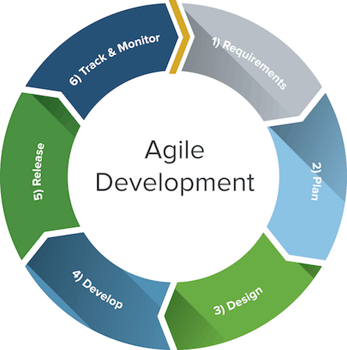

Figure 0.2(Sohail, 2019)

## 

## 3.2.1 System Requirements Phase

This phase involves defining the problem, objectives or need that requires resolution and the functional and quality requirements of the system. It involves system designers, developers and users (Sohail, 2019).

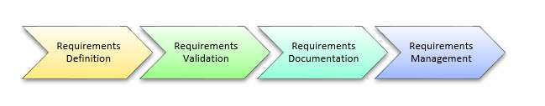

Figure 0.3(Guru99, 2015)

The requirements include end user functional needs and technical and physical attributes defining operational and engineering parameters guided by the Requirement Life Cycle represented by figure 3.3 above. The table below table 3.1 shows the project stakeholders we interviewed (see Appendix A) to find out the challenges they face, then formulated requirements, validated them using Test case technique and documented the requirement using a system Requirement document and the requirements are managed using the Visure requirement management tool because it allows collaboration using teams and risk management and full traceability of the requirements.

|  |  |  |  |  |
| --- | --- | --- | --- | --- |
| **STAKE-HOLDERS** | **CONTRIBUTION** | **WILLINGNESS** | **INFLUENCE** | **NECESSITY OF INVOLMENT** |
| Government | High:  Knowledge in standards of sustainable housing and housing policies | High:  They are directly affected since they create the standards and ensure they implementation | High:The government is the owner of the Boma yangu app they provide the laws and guide the procedures and standards of the system | High:  They need to Validate each functionality nad the legality of the same |
| Construction Managers | High: Provide costs of materials ,labour and other expenses used in cost estimation and budgeting. | High: They are directly affected since they are involved in the construction of affordable accommodation for Kenyans | High: They usability of the app needs to be easy and comfortable and the accuracy of estimation dependes of their expertise since they are experienced in construstion | High:  They need to Validate each functionality. |
| Homeowners | Low: Provide the challenges they face | High: They are directly affected they are the people who buy the government houses or face the risk of their houses being demolished | High:  They provide the preference of the houses | Low:  They do not need to be actively involved in the development and monitoring. |
| Land Owners | Low: Provide the challenges they face | High: They are directly affected since they face the risk of being scammed | Low:They just provide their experience and processes involved in owning land | Low: They do not need to be actively involved in the development and monitoring. |
| Tenants | Low: Provide the challenges they face | High: They are directly affected since they face the risk of being victims of demolited houses | Low:They just provide their experience as tenants | Low: They do not need to be actively involved in the development and monitoring. |

Figure 0.4 ShareHolder mapping table summary

## 3.2.2 System Planning Phase

Based on the requirements provided a plan is developed to provide an estimate of project scope and application requirements are done at this phase(Sohail, 2019). This is done by reviewing the literature review so as to understand how other tools work and understand the aspects being covered and so as to understand the scope not covered.

The information collected will be used in identifying the communication plan for stakeholders, the identification of the critical path, business needs, resource allocation, project scope, constraints, dependencies and risk assessment. The tools used here is Meister Task integrated with Mind Meister for creating maps that draft the initial structure of the project. Meister task uses a board to show all the tasks allocated to team members, Emails and appointments will be made monthly to review the project progress.

## 3.2.3 System design phase:

It involves the actual development of the system through programming, testing, and integration activities(Sohail, 2019). The requirements defined in the first phase is used to establish a baseline of system and subsystem specifications that describe the parts of the system, how they interface, and how the system will be implemented using the chosen hardware, software and network facilities. Generally, the design also includes program and database specifications. For this study object oriented analysis will be used to form incremental designs and analysis, Some typical input artifacts for object-oriented design are:

[Use case](https://en.wikipedia.org/wiki/Use_case): A description of sequences of events that, taken together, lead to a system doing something useful. Each use case provides one or more [scenarios](https://en.wikipedia.org/wiki/Scenario_(computing)) that convey how the system should interact with the stakeholders called actors to achieve a specific business goal or function. Unified Modelling Language (UML) will be used as the modelling language. This will have aided in modelling analysis and design diagrams. Other than that the UML notation offered clarification to user requirements. Use Case descriptions and diagrams will be used to model system functionality. The System Sequence Diagram modelled the System Flow showing data passing between main entities of the system. Various entities with corresponding attributes and methods of implementation is modelled using Class diagrams. The Entity Relationship Diagram will be used to model the database. This showed the tables, attributes and relationships. The Database Schema modelled the table structure showing fields, data types and descriptions.

## 3.2.4 System Development phase

It involves the development of the system as per the plan, design and requirements of all the stakeholders listed in the first three stages (Sohail, 2019). Various level of testing occurs in this phase to verify and validate what has been developed. This includes all unit and system testing and several iterations of user acceptance testing.

In this phase, the design was converted into a complete tool. Activities done in this stage includes testing, compiling and debugging code. This phase was allocated most of the time. Those features considered important to be in the system, were incorporated. The following tools were used:

1. Xampp SQL database: It was used in access control as well as evidence storage. It is an open source project which belongs to Apache Friends.

2. Sublime Text 3: This is an editor that was used in writing the code.

3. Laravel PHP Framework version 6.0 , It will help in simplifying the development process, since it uses the Model View Control that simplifies the development of each module that is the functionalities and what the user will see.

4. Windows operating system: This is the platform where the above tools will be installed. It is owned by Microsoft Corporation

**System Testing**

Testing is a crucial step that is taken before an application is deployed. The application is

executed so that the errors can be found and debugged to solve the errors. Five testers,

selected randomly, tested components of the system. There were five modules in the system

each were tested individually with functional, non-functional, structural, security and

usability and unit testing methods.

1. Functional Testing Functional testing involves aspects of the tool which directly affects the functioning of the system such as the features. The functional testing on the tool will be conducted on the following aspects:
   1. The budget generating function is almost accurate and predicts changes in market and inflammation.
   2. Security in purchasing land is ensured by cross checking title deeds in the government database, the payment methods are secure.
   3. Installation and deployment of the setup in different environments and platforms.
   4. Access control to the system.
   5. Test for core application features such cost estimation, planning segment and legal validity of documents.

b) Non-Functional Testing

These tests are conducted to the application on aspects that are not directly related to the functioning of the system. The non-functional testing of the tool was done to the following areas:

1. Quality assurance is to be conducted to the source code to ascertain whether it meet logical requirements.

2. Enhancing user interface.

3. Testing on resource optimization in terms of storage and speed in accessing resources such as the title deeds of lands.

c)Structural Testing

In structural testing, tests are derived from the knowledge of the software’s structure or internal implementation. Structural testing is critical because the output of the tool is meant for the forensics process. The use of an existing framework helped in reducing the number of errors because the bugs had been identified and improved on. The development process involved constant peer review to counter check the logic of the code.

d) Usability Testing

User testing refers to a technique used in the design process to evaluate a product, feature or prototype with real users. The primary goal of usability test is to prove that the product can be used in the actual budgeting of constructing buildings for the government and the security of the transaction between landowners and potential buyers. Usability testing focuses on measuring a human-made product's capacity to meet its intended purpose.

e) Unit Testing

This is the most important type of testing. It involves breaking the program into pieces and subjecting each piece into a series of tests and testing individual modules. The tests were run periodically after every change to the source code to limit future problems. A set of test cases which focus on the control structure of the procedural design to be used. Tests includes checking whether the helper classes returned the right results and whether the internal operation of the program performs according to specification.

f) Integration Testing

It is a test that evaluates the connection of two or more components that pass information from one area to another. The objective was to take unit-tested modules and build an integrated structure dictated by design. The term integration testing is also used to refer to tests that verify and validate the functioning of the application under test with other systems, where a set of data is transferred from one system to another.

g) Compatibility Testing

Tests that were done in the compatibility testing included browser compatibility testing which was the most important compatibility test. It checked compatibility of the three major browsers which are Chrome (version 65.0.3325.181 (Official Build) (64-bit)), Firefox (version 59.0.2 (64-bit)) and Microsoft Edge (version 38.14393.2068.0) to check the compatibility of the software applications. The next test involved the hardware. Checks included software compatibility with the host hardware configuration such as allocated memory and processor time. A network test was also carried out to evaluate the performance of the system in a network with varying parameters such as Bandwidth, Operating speed and Capacity.

## 3.2.5 System Release phase

It involves establishing the actual operation of the new system developed (Sohail, 2019). The final iteration of user acceptance testing and user sign-off is conducted in this phase. The system also may go through checks to ensure that it is effective in meeting its intended objectives as per the requirements phase. This phase is where system specification is converted into an executable system. This phase deals with addressing these issues that may not have been considered in other phases that came before. In this phase the end user who in this case is the investigators is trained on system use and also given the documentation. The end gets intensive support, hyper-care, required during initial use of the new system. In this phase is where the system is handed over to the support team or the end user.

## 3.2.6 System Track and Monitor phase

Following the successful implementation of the system. The system is kept on random checks which may include simultaneous audit to assess the effectiveness of the system in meeting the desired objectives(Sohail, 2019). System track and monitor deals with collecting the user feedback and work it into the requirements for the next project.

### 3.3. Project Milestones/ Schedule

[Here you are expected to describe and attach a graph (Gantt Chart) from either MS. Visio or MS Project etc.] – This could be the plan of work that you have for your team.

### 3.4. Impact Assessment

Impact assessment is the further analysis of requirements to prepare facts and figures for a business analyst to track possible result based on analysis

How would you conduct an impact assessment?

# Chapter 4: Empathy, Problem Definition and Ideation

## 4.1. Empathy

Use the various data collection methods to collect data regarding your challenge. The generic and easily accessible method is usually Document review, but there are many other direct (primary data) methods that you can use to get data including interviews, observation, questionnaires etc. Summarize your findings (data collected) in this section. Present/summarize the data per (based on) each stakeholder. Also remember to clearly describe how the data was collected.

## 4.2. Problem Definition

Clearly Define the problem (s) based on your findings at the Empathy stage.

## 4.2. Ideation

Using a table format, list various ideas of how to address the problem. For each idea, state why it is recommended. Rank the ideas based on the ability to address the problem(s)

# References

Abrahmsson, P., Salo, O., & Warsta, J. (2002). Agile Development Software Methods: REview and Analytics. VTT Electronics.

Boem, B., & Turner, R. (2003). Balancing Agility and Discipline. A guide for the perplexed

Gajos, P. (2015). What is Agile Development for mobile apps? Retrieved from http://sourcebits.com/app-development-design-blog/what-is-agile-development-formobile-apps/

# 

# Appendices

**Appendix A: Questionnaire Used**

**Appendix B :Interview Questions Used**

**Appendis C : Usability Test Questionnaire**